Lesson 3 Extended Kalman Filters

[1. Sebastian Introduction](https://classroom.udacity.com/nanodegrees/nd787/parts/a1505b23-c1aa-4bc6-a94c-d44d062d0209/modules/19b5af05-2ec7-491a-94db-1befc15d07c0/lessons/8f586008-3e4f-47a1-bde5-e43c184b49d2/concepts/b7e6f40b-a5bb-4d11-9a89-91cacbb927c2)

<https://www.youtube.com/watch?time_continue=6&v=NwZi7JshQeE>

[2. Introduction](https://classroom.udacity.com/nanodegrees/nd787/parts/a1505b23-c1aa-4bc6-a94c-d44d062d0209/modules/19b5af05-2ec7-491a-94db-1befc15d07c0/lessons/8f586008-3e4f-47a1-bde5-e43c184b49d2/concepts/5eeb6569-84b3-4867-9d4f-9d94e0e80036)

<https://www.youtube.com/watch?v=WleBZHdI_vc>

[3. 1D PID Control](https://classroom.udacity.com/nanodegrees/nd787/parts/a1505b23-c1aa-4bc6-a94c-d44d062d0209/modules/19b5af05-2ec7-491a-94db-1befc15d07c0/lessons/8f586008-3e4f-47a1-bde5-e43c184b49d2/concepts/aa10818e-129e-4c39-9188-7741b5c351ff)

<https://www.youtube.com/watch?time_continue=2&v=Y9A6W9TXnxE>

[4. Controlling with Noisy Measurements](https://classroom.udacity.com/nanodegrees/nd787/parts/a1505b23-c1aa-4bc6-a94c-d44d062d0209/modules/19b5af05-2ec7-491a-94db-1befc15d07c0/lessons/8f586008-3e4f-47a1-bde5-e43c184b49d2/concepts/75a39212-e077-443b-8731-ffc2ecd3e295)

<https://www.youtube.com/watch?time_continue=2&v=j0KuThQUQZQ>

[5. Averaging Measurements](https://classroom.udacity.com/nanodegrees/nd787/parts/a1505b23-c1aa-4bc6-a94c-d44d062d0209/modules/19b5af05-2ec7-491a-94db-1befc15d07c0/lessons/8f586008-3e4f-47a1-bde5-e43c184b49d2/concepts/a6ef032b-61a6-486e-9ba2-cd65acc056ec)

<https://www.youtube.com/watch?v=C2EvnerFork>

[6. Recursive Averaging](https://classroom.udacity.com/nanodegrees/nd787/parts/a1505b23-c1aa-4bc6-a94c-d44d062d0209/modules/19b5af05-2ec7-491a-94db-1befc15d07c0/lessons/8f586008-3e4f-47a1-bde5-e43c184b49d2/concepts/78752b80-cd67-42eb-9b12-4babec6277c7)

<https://www.youtube.com/watch?v=WEBwezpZ5nQ>

[7. Averaging Exercise](https://classroom.udacity.com/nanodegrees/nd787/parts/a1505b23-c1aa-4bc6-a94c-d44d062d0209/modules/19b5af05-2ec7-491a-94db-1befc15d07c0/lessons/8f586008-3e4f-47a1-bde5-e43c184b49d2/concepts/e15c3011-968b-4df5-995d-3f9cc28e9c0d)

[Averaging-Student.ipynb](https://view777be406.udacity-student-workspaces.com/notebooks/Averaging-Student.ipynb)

[8. The Need for Control](https://classroom.udacity.com/nanodegrees/nd787/parts/a1505b23-c1aa-4bc6-a94c-d44d062d0209/modules/19b5af05-2ec7-491a-94db-1befc15d07c0/lessons/8f586008-3e4f-47a1-bde5-e43c184b49d2/concepts/3587f5a4-b53e-4ede-bdf2-a70ca7aa9785)

<https://www.youtube.com/watch?time_continue=1&v=ITakz4-3xtw>

[9. Estimation Filters](https://classroom.udacity.com/nanodegrees/nd787/parts/a1505b23-c1aa-4bc6-a94c-d44d062d0209/modules/19b5af05-2ec7-491a-94db-1befc15d07c0/lessons/8f586008-3e4f-47a1-bde5-e43c184b49d2/concepts/302be7d1-123c-418a-a281-dc4cdf43d733)

<https://www.youtube.com/watch?time_continue=3&v=ed4queOTU7A>

[10. The Bayes Filter](https://classroom.udacity.com/nanodegrees/nd787/parts/a1505b23-c1aa-4bc6-a94c-d44d062d0209/modules/19b5af05-2ec7-491a-94db-1befc15d07c0/lessons/8f586008-3e4f-47a1-bde5-e43c184b49d2/concepts/3a34889f-362c-4c78-af05-b8fded786237)

<https://www.youtube.com/watch?v=aRUyud9H2Dc>

To help summarize this lesson and the next, we've made a document called [Estimation for Quadrotors](https://www.overleaf.com/read/vymfngphcccj).

Learning about estimation filters involves a lot of math and sometimes math is best learned by reading through text at your own pace. You are encouraged to open this document and consult it as an additional resource as you go through this lesson and the next.

[11. The Kalman Filter](https://classroom.udacity.com/nanodegrees/nd787/parts/a1505b23-c1aa-4bc6-a94c-d44d062d0209/modules/19b5af05-2ec7-491a-94db-1befc15d07c0/lessons/8f586008-3e4f-47a1-bde5-e43c184b49d2/concepts/9a484483-041b-4421-a584-a8d5e225ce7c)

<https://www.youtube.com/watch?v=t_nR08qDHX4>

[12. Kalman Predict](https://classroom.udacity.com/nanodegrees/nd787/parts/a1505b23-c1aa-4bc6-a94c-d44d062d0209/modules/19b5af05-2ec7-491a-94db-1befc15d07c0/lessons/8f586008-3e4f-47a1-bde5-e43c184b49d2/concepts/6b6f5a9f-9961-48c4-bb87-38a7567aa664)

<https://www.youtube.com/watch?time_continue=2&v=uk6aplXeAg8>

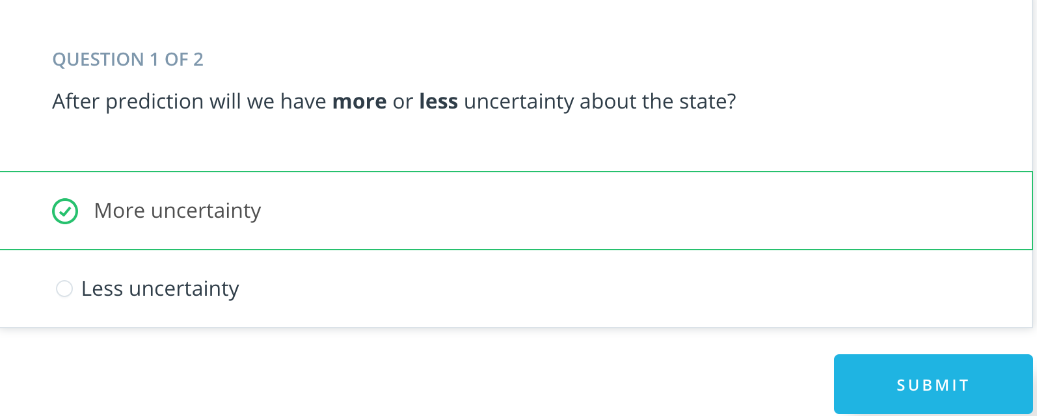

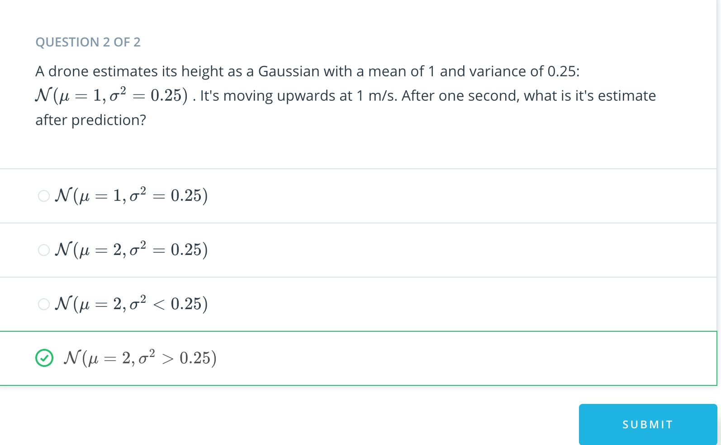

[13. The Measurement Function](https://classroom.udacity.com/nanodegrees/nd787/parts/a1505b23-c1aa-4bc6-a94c-d44d062d0209/modules/19b5af05-2ec7-491a-94db-1befc15d07c0/lessons/8f586008-3e4f-47a1-bde5-e43c184b49d2/concepts/1ad2dac1-25ea-42f2-bf8f-3a4077adcbc5)

<https://www.youtube.com/watch?time_continue=1&v=R61K0yzKWOk>

[14. Kalman Update](https://classroom.udacity.com/nanodegrees/nd787/parts/a1505b23-c1aa-4bc6-a94c-d44d062d0209/modules/19b5af05-2ec7-491a-94db-1befc15d07c0/lessons/8f586008-3e4f-47a1-bde5-e43c184b49d2/concepts/3cfd400d-f659-4f05-b52e-3e74a47baab7)

<https://www.youtube.com/watch?v=nrONt9rDEvg>

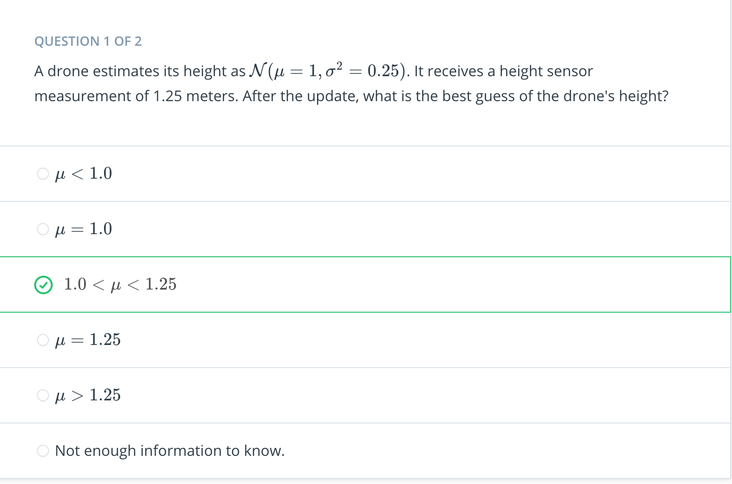

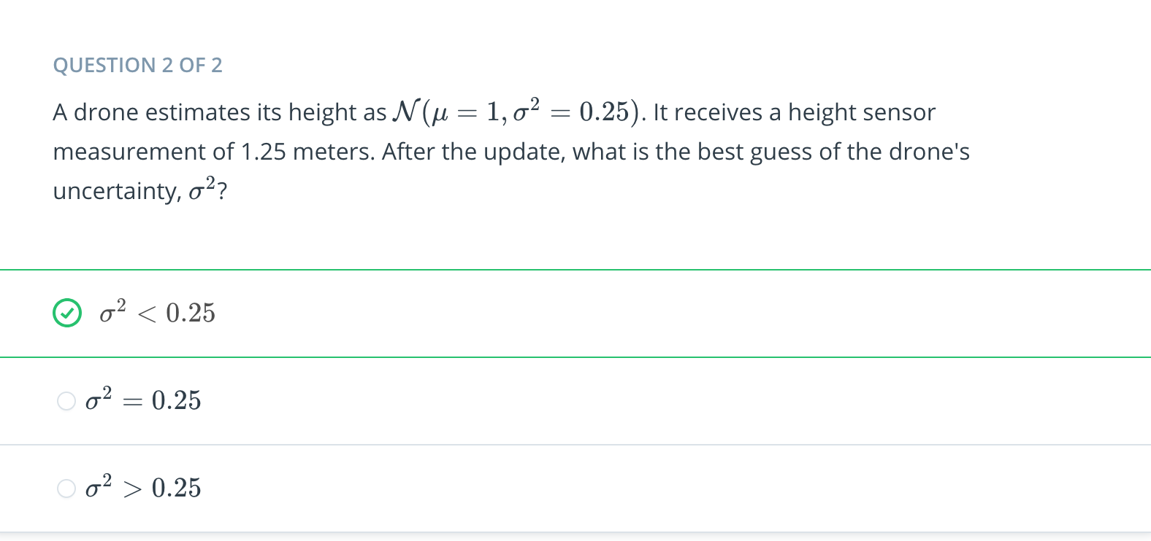

[15. Kalman Filter Exercise](https://classroom.udacity.com/nanodegrees/nd787/parts/a1505b23-c1aa-4bc6-a94c-d44d062d0209/modules/19b5af05-2ec7-491a-94db-1befc15d07c0/lessons/8f586008-3e4f-47a1-bde5-e43c184b49d2/concepts/97a5086e-0535-4a9f-946c-3bb18ef8b107)

[Kalman_Filter-Student.ipynb](https://view9d00f7db.udacity-student-workspaces.com/notebooks/Kalman_Filter-Student.ipynb)

[16. Nonlinear Drone](https://classroom.udacity.com/nanodegrees/nd787/parts/a1505b23-c1aa-4bc6-a94c-d44d062d0209/modules/19b5af05-2ec7-491a-94db-1befc15d07c0/lessons/8f586008-3e4f-47a1-bde5-e43c184b49d2/concepts/9e7ca17a-a4ea-4133-a415-c766b315e2c0)

<https://www.youtube.com/watch?time_continue=2&v=23dKxgmrdd0>

[17. EKF Predict](https://classroom.udacity.com/nanodegrees/nd787/parts/a1505b23-c1aa-4bc6-a94c-d44d062d0209/modules/19b5af05-2ec7-491a-94db-1befc15d07c0/lessons/8f586008-3e4f-47a1-bde5-e43c184b49d2/concepts/35d1767d-1570-48cc-96dd-356a80c6d55e)

<https://www.youtube.com/watch?time_continue=3&v=-VvvbI8HdRw>

[Sympy Demonstration.ipynb](https://view015a4448.udacity-student-workspaces.com/notebooks/Sympy%20Demonstration.ipynb)

[18. Non-linear Measurement Model](https://classroom.udacity.com/nanodegrees/nd787/parts/a1505b23-c1aa-4bc6-a94c-d44d062d0209/modules/19b5af05-2ec7-491a-94db-1befc15d07c0/lessons/8f586008-3e4f-47a1-bde5-e43c184b49d2/concepts/51c4660c-8889-448d-9f3d-4bd1c3495e43)

<https://www.youtube.com/watch?time_continue=2&v=l8g-8PLwKvw>

[19. EKF Update](https://classroom.udacity.com/nanodegrees/nd787/parts/a1505b23-c1aa-4bc6-a94c-d44d062d0209/modules/19b5af05-2ec7-491a-94db-1befc15d07c0/lessons/8f586008-3e4f-47a1-bde5-e43c184b49d2/concepts/616d0596-f236-4d6c-8da7-720e113d0481)

<https://www.youtube.com/watch?time_continue=1&v=HzNYY1U_0Ys>

[20. EKF Exercise](https://classroom.udacity.com/nanodegrees/nd787/parts/a1505b23-c1aa-4bc6-a94c-d44d062d0209/modules/19b5af05-2ec7-491a-94db-1befc15d07c0/lessons/8f586008-3e4f-47a1-bde5-e43c184b49d2/concepts/039ed41d-8af3-4a6a-bf3a-899323627a2e)

[EKF-Student.ipynb](https://view015a4448.udacity-student-workspaces.com/notebooks/EKF-Student.ipynb)

[21. Summary](https://classroom.udacity.com/nanodegrees/nd787/parts/a1505b23-c1aa-4bc6-a94c-d44d062d0209/modules/19b5af05-2ec7-491a-94db-1befc15d07c0/lessons/8f586008-3e4f-47a1-bde5-e43c184b49d2/concepts/3134efdc-066a-439e-a7e2-5b9a61a076c6)

<https://www.youtube.com/watch?v=hBSEeUh6Uhc>